WILLOWBANK HOTEL, 96 GREENOCK ROAD, LARGS KA30 8PG
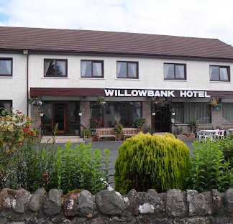

LUNCH MENU SATURDAY 10 JANUARY 2026
Starters
Chilled Fruit Juice
Chef’s Pate Maison
Citrus Cocktail
Homemade Soup of the Day
*****
Mains
Fresh Fillet of Breaded Haddock
Roast Breast of Chicken Grandmere
Roast Beef & Diane Sauce
Assorted Cold Meat Salad
Served with French Fries and Vegetables
*****
Desserts
Scotch Trifle
Peach Melba
Assorted Dairy Ices
****
Coffee/Tea

