Saturday 10 December
Pre-Xmas Overnight stay
Dinner, Bed and Breakfast - £55pp

The Highlander Hotel, Newtonmore

In previous years the club have enjoyed a Xmas overnight stay at the Highlander Hotel in Newtonmore which included a party night.

The hotel no longer do party nights but are putting on a festive dinner followed by entertainment (Hotel description: Kenny Nairn is booked, he plays the accordion and sings and does ceilidh to YMCA and everything in between, great to have a boogie to of any sort) with the evening finishing at approximately 11.30pm. The cost of this would be £55 per person for dinner, bed and breakfast. The cost for sole occupancy rooms would be the same but they are asking if people could share where possible.

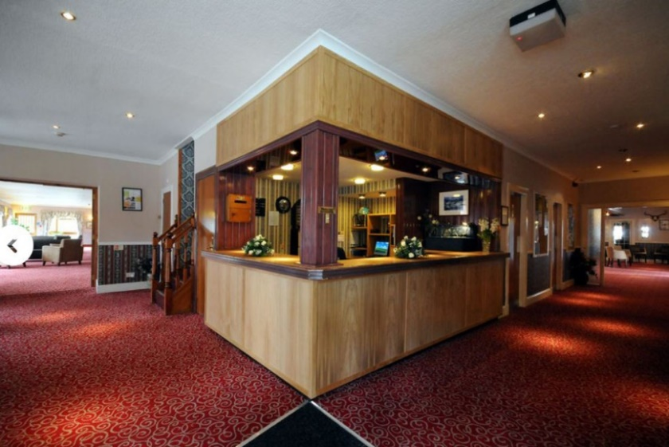
The hire of our usual coach would prove too costly but Citylink buses stop near the hotel with one change required or a train from Glasgow to Newtonmore is another option, but with the ongoing train strikes this would be unknown until nearer the time. The drive time if anyone wanted to take their own car is just over two hours.

If anyone thinks they may be interested can they please advise Christine asap in order that we can secure rooms, either by email at cmrambler@talktalk.net or text 07837 990985 with name(s) and room type.

